RC, Op Amp, Inductor Circuits

Experiment 1, 2, and 3

Justin Fortner

February 24th, 2018

Section 04 Wednesday 12:20-2:20 (Tuwin)

**Introduction**

The purpose of lab 3 was to allow the student to observe the charging and discharging phase of capacitors, OpAmps and inductors. This is done by applying a square wave to each individual circuit and observing the resulting waveform.

Experiment 1 focuses on the charging and discharging phase of a capacitor. This observation is made at two different frequencies. One at 1/frequency and one at 1/frequency . In addition to the charging and discharging phase of a capacitor, the voltage drop across the resistor, the input voltage, capacitor voltage, and current waveforms must all be observed and recorded.

Experiment 2 focuses on the charging and discharging phase of a RC circuit built using an OpAmp. This observation is made at two different frequencies. One at 1/frequency and one at 1/frequency . In addition to the charging and discharging phase of a capacitor, the voltage drop across the resistor, the input voltage, capacitor voltage, and current waveforms must all be observed and recorded.

Experiment 3 focuses on the charging and discharging phase of an inductor in a passive RL. This observation is made at one different frequency.

**RC Circuit**

The circuit in **Figure 1** must be completed in order to complete experiment 1.

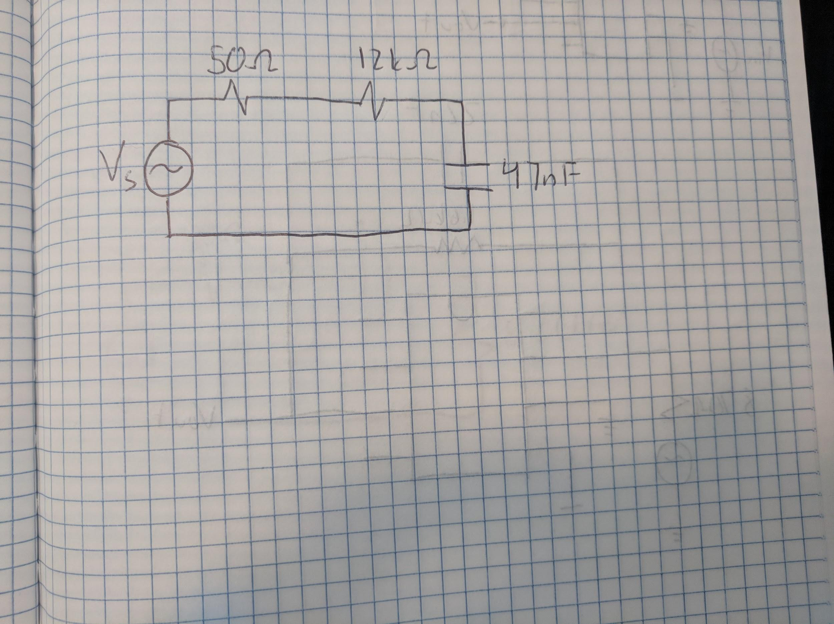

**Figure 1**

RC Circuit Schematic for Lab 3, Experiment 1

A 12 k resistor was used in series with a 47nF capacitor in order to replicate the circuit in **Figure 1**. The time constant was found to be .000564 seconds. In order to properly observe the charging and discharging of the capacitor a square wave was applied to the circuit in **Figure 1**. This square wave had a peak to peak voltage of 200mV and frequency of 40Hz. This frequency was used in order to allow the period to be long enough to observe a complete charge and discharge of the capacitor. In order to properly view the resulting waveforms for the capacitor the probes must be connected before the 12kΩ resistor and after the 47nF capacitor**.** Then they must both be grounded to the connection between the 12kΩ resistor and the 47nF capacitor. The resulting waveform values for the capacitor can be viewed in **Figure 2**.

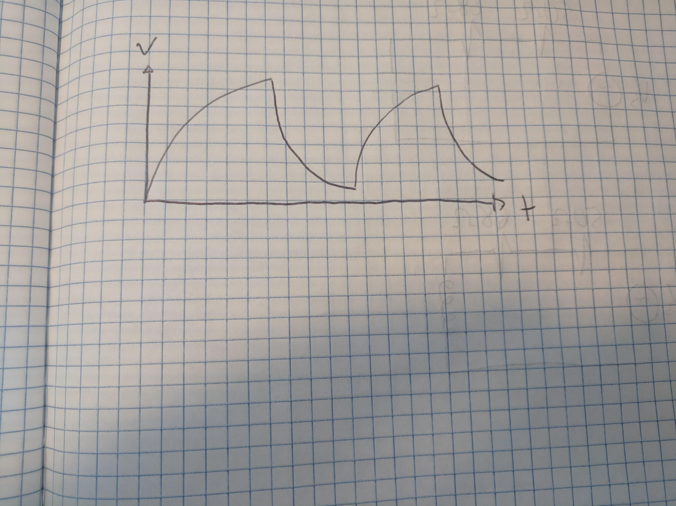

**Figure 2**

RC Circuit Waveform for Lab 3 (40Hz), Experiment 1

The capacitor is given time to charge fully and level out the top curve before being discharged and leveling out on the bottom. Giving this cliff like graph.

Both theoretical and actual numbers are calculated/observed at 12.5 microseconds. The theoretical predictions for an ideal RC circuit for voltage and current are 118.2*V and 9.833. The actual values of voltage and current are 111*V and 9.25. When compared we can see that the theoretical voltage is 6.4 % greater than the actual voltage. This could be due to an unknown variance in the capacitance. The error in voltage would also lead to the 6.3% difference observed when calculating the currents. As we can observe in the graph in **Figure 2** the capacitor will slowly charge over time and then discharge over time. This is shown by the upwards slope of the graph when the input voltage is high and the downwards sloping of the graph when the input voltage is low. According to Lens’s law the capacitor will always generate a current that opposes a changing voltage. Thus the direction and shape of the current graph will be exactly opposite of the voltage graph.

The capacitor will consume power from the circuit until the capacitor voltage will equal the input voltage. Once the voltages are equal the capacitor will discharge a lot of power very quickly. The passive sign convention still applies here as the total power released by the capacitor will never be greater than the power supplied to the capacitor.

This capacitor voltage is in integration of the input voltage. We can see this through the evolution of .

While not as obvious, many of the same observations can be seen if the frequency was changed to 500Hz. Once again, in order to properly view the resulting waveforms for the capacitor the probes must be connected as explained after **Figure 1.** The resulting waveform values for the capacitor can be viewed in **Figure 3**.

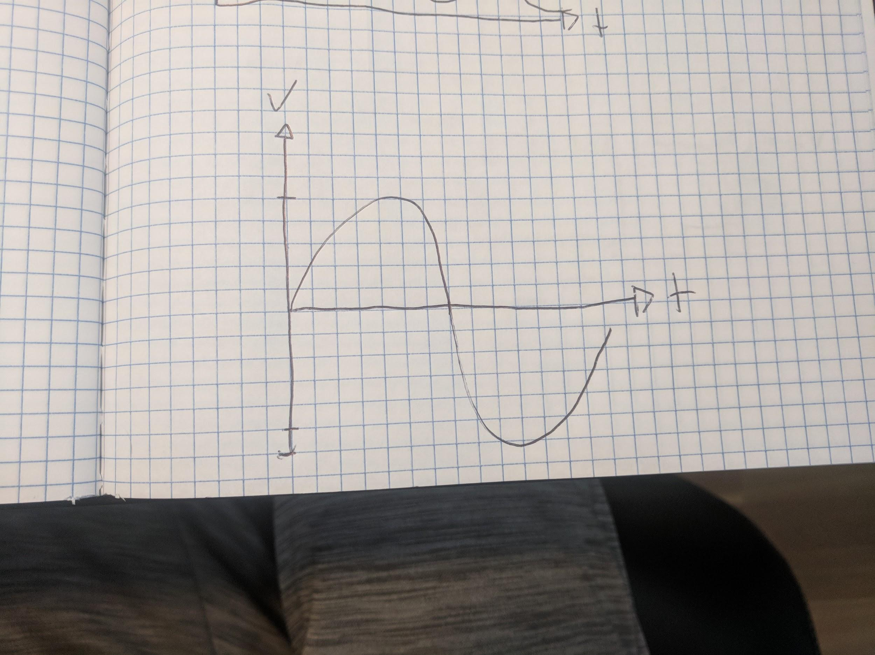

**Figure 3**

RC Circuit Waveform for Lab 3 (500Hz), Experiment 1

Here the capacitor is not given enough time to fully charge before being discharged. Thus resulting in this bell shaped graph rather than the cliff graph observed above.

Both theoretical and actual numbers are calculated/observed at 1.5 microseconds. The theoretical predictions for an ideal RC circuit for voltage and current are 15.08* and 1.26. The actual values of voltage and current are 14.5* and 1.21 . When compared we can see that the theoretical voltage is 4% greater than the actual voltage. This could be due to an unknown variance in the capacitance. The error in voltage would also lead to the 4.1% difference observed when calculating the currents.

This circuit is an integrator circuit. We know this because the output voltage of an integration circuit is proportional to the product of the input voltage and time. When we observe the output voltage of this circuit in **Figure 2**. We see that as time increases the output voltage of the capacitor increases until the capacitor discharges.

**OpAmp Circuit**

The circuit in **Figure 4** must be completed using a 741 Op Amp in order to complete experiment 2. Just as in experiment 1, this circuit is an integrator circuit.

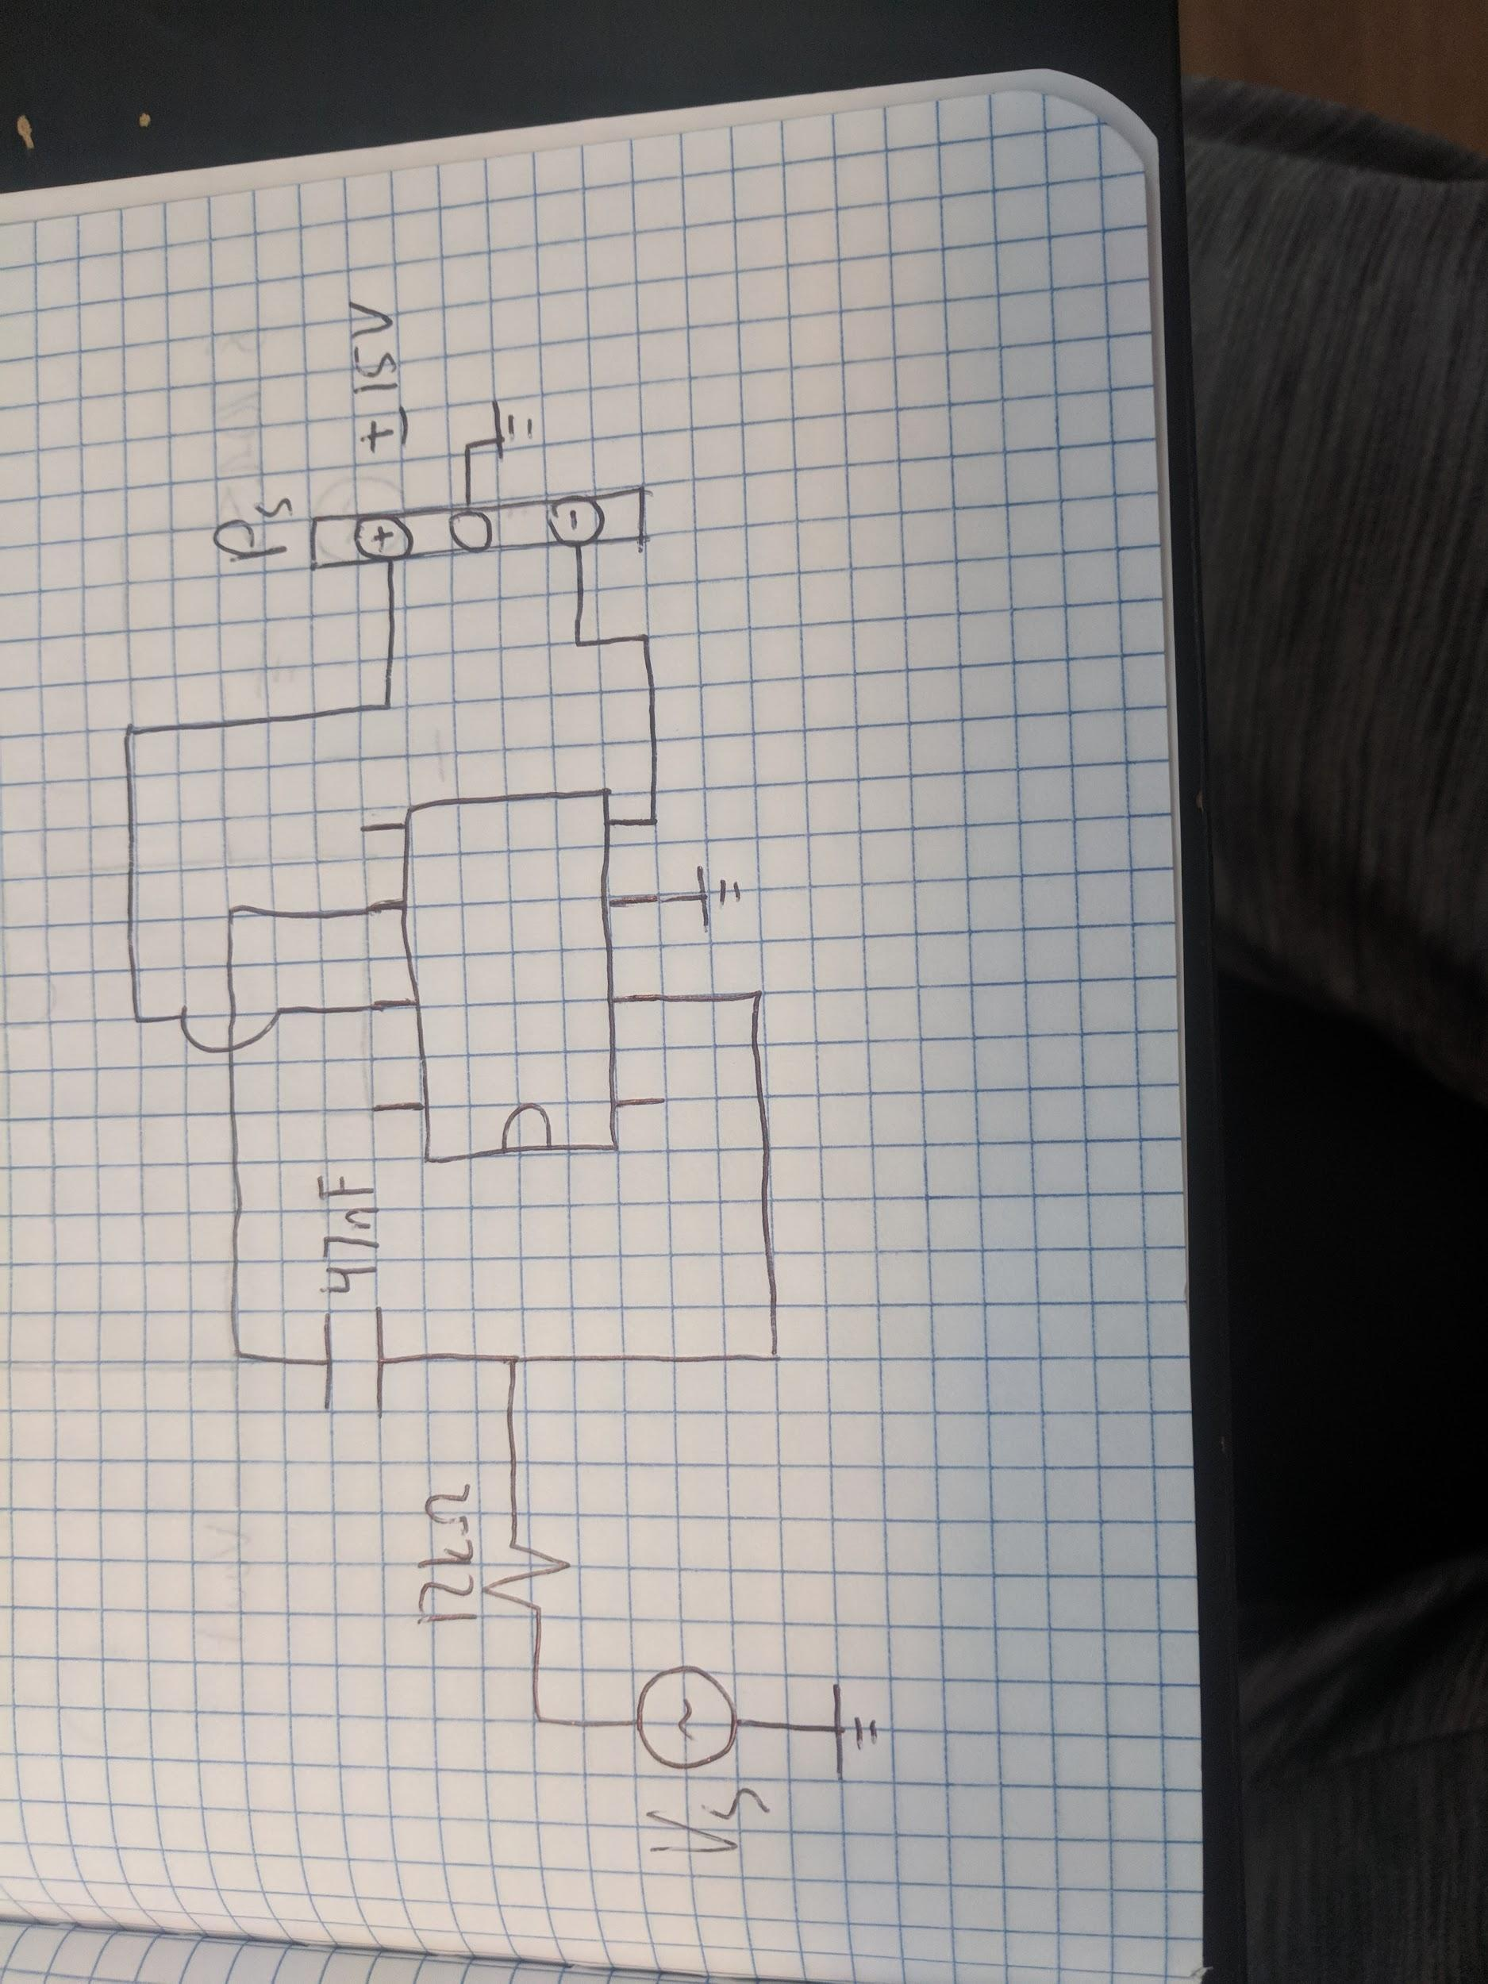

**Figure 4**

Op Amp Circuit for Lab 3, Experiment 2

A 12 k resistor was used in series with a 47nF capacitor in order to replicate the circuit in **Figure 4**. The power source was sev to have a +15V and a -15V in order to meet the required connections, +Vcc and -Vcc, of our OpAmp. A square wave was applied to this circuit. This square wave had a peak to peak voltage of 200mV and frequency of 40Hz. The resulting waveform values for the capacitor can be viewed in **Figure 5**.



**Figure 5**

OpAmp Circuit Waveform for Lab 3 (40Hz), Experiment 2

When the frequency is changed to 500Hz the waveform changes. Once again this is an integrator circuit. The resulting waveform values can be viewed below in **Figure 6**.



**Figure 6**

OpAmp Circuit Waveform for Lab 3 (500Hz), Experiment 2

If we are considering the 741 OpAmp to be ideal then the value would be the same from experiment 1 due to there being no output resistance.. However, no OpAmp is truly ideal. Thus, the 741 OpAmp would have an output resistance. This output resistance would change the for experiment 2. According to **Figure 6 t**he charging/ discharging time for the capacitor in this active integrator circuit would be 1.21 milliseconds.

**RL Circuit**

The circuit in **Figure 7** must be completed in order to complete experiment 1. However, the capacitor must be replaced with an inductor.

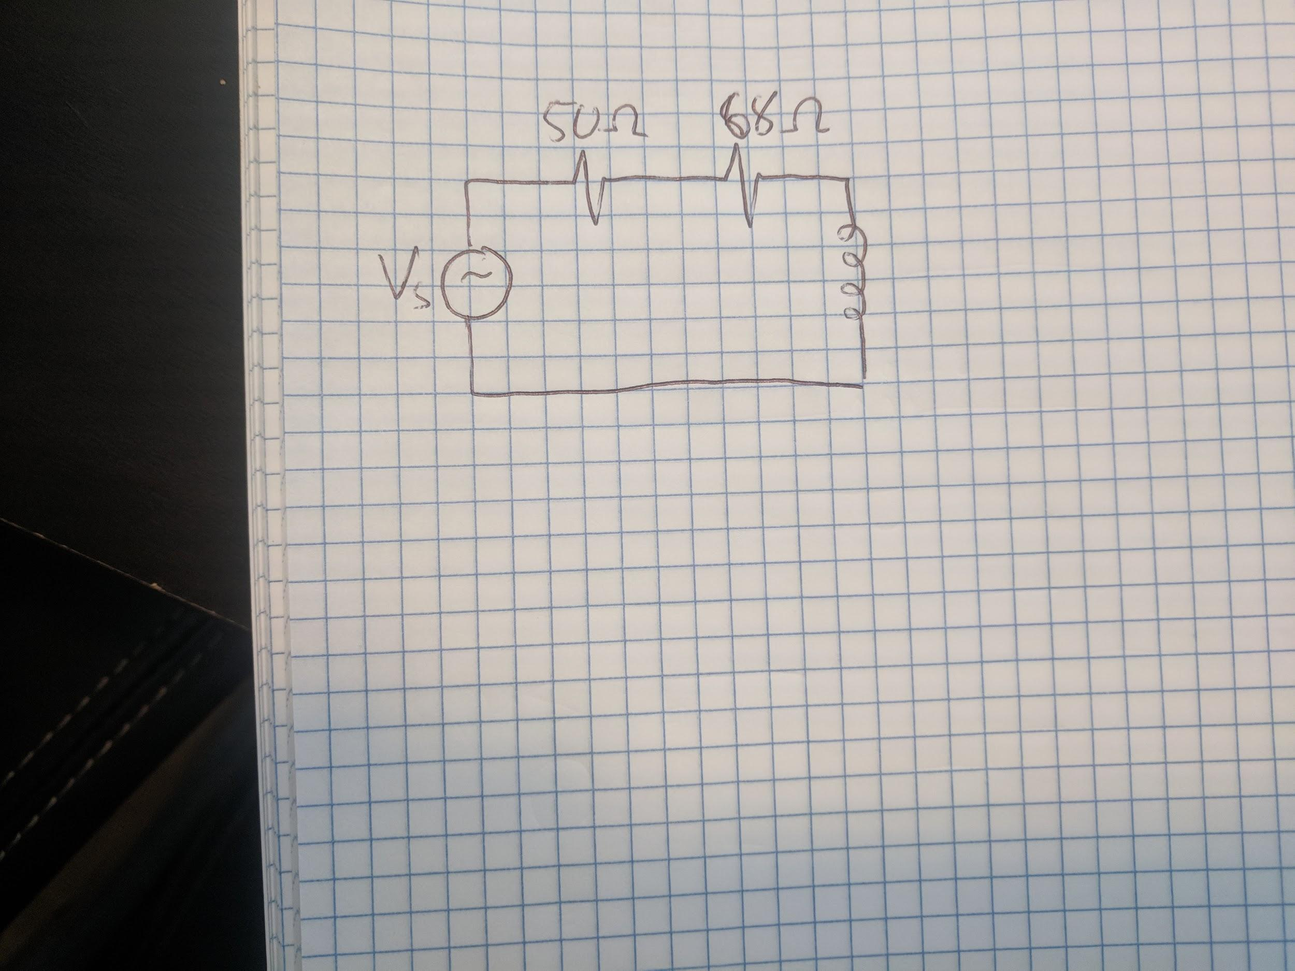

**Figure 7**

RL Circuit Schematic for Lab 3, Experiment 3

A 68 resistor was used in series with the inductor in order to replicate the circuit in **Figure 7**. In order to properly observe the inductor waveforms a square wave was applied to the circuit in **Figure 7**. This square wave had a peak to peak voltage of 200mV and frequency of 4.2 kHz. This frequency was used in order to allow for the observation of transient behavior of the inductor. In order to properly view the resulting waveforms for the capacitor the probes must be connected with one probe connected before the 68Ω resistor and one after the 68Ω. With both probes grounded after the inductor. The resulting waveform values for the capacitor can be viewed in **Figure 8**.



**Figure 8**

RL Circuit Waveform for Lab 3 (4.2 kHz), Experiment 3

63% of the voltage drops across the resistor in 75 anano seconds. Using this information we can deduct that the inductance of the inductor provided in the lab is roughly 10mH.

**Conclusion**

I had a fairly successful lab in lab 3. I successfully completed all three experiments. I had some trouble following the original lab manual but thankfully my TA was able to give us a more in depth lab manual. This was extremely helpful in both completing the lab and understanding all the material meant to get out of doing the lab.

For experiment 1 and 3. I was able to successfully create the circuit and test with two different frequencies. I was able to safe the data is a CSV file which can be seen in the appendices of this lab. I successfully identified the voltage from the capacitor and compared this value to my prediction. I did notice that in both frequencies in both experiment 1 and 2 the predicted voltage is higher than the actual voltage. I believe this to be the result in a variance of the capacitance value.

For experiment 3, I successfully created the desired circuit , predicted a close inductance value and found the true inductance value. My prediction was very close to the actual value of the inductor.

This was a great lab, I accomplished and learned a lot. I was able to not only memorize but understand the key aspects of this lab.